AI on the Move: Distributed Intelligence in Smart Grids and Predictive Maintenance

Matthew Naughton
Northeastern University
ALY 3510: AI Foundations: An Interdisciplinary Approach
Professor Vladimir Shapiro
Fall 2026

AI on the Move: Distributed Intelligence in Smart Grids and Predictive Maintenance
Introduction
Most people picture artificial intelligence as a single powerful program running somewhere in the cloud. Distributed AI inverts that model. Rather than relying on one central system to make every decision, it spreads intelligence across many smaller agents that can make decisions locally while still working toward a common goal. These agents may cooperate, share information, or respond to changing conditions without waiting for instructions from a central controller.
Coming from facilities engineering, the concept immediately reminded me of how complex systems operate in the real world. Whether it is a building, a utility network, or a maintenance program, success often depends on many specialized components performing their own functions while contributing to a larger objective. This paper explains distributed AI in plain terms, explores two real-world applications that relate to my professional interests, examines one challenge and one advantage of distributed systems, and reflects on a perspective that changed the way I think about distributed intelligence.
What Distributed AI Is
In a centralized AI system, data is collected in one place, decisions are made by a single model, and instructions are distributed back to the system. Distributed AI replaces that single decision-maker with multiple agents operating across a network. Each agent has access to local information, can make decisions independently, and contributes to the overall behavior of the system (IBM, n.d.).
Distributed AI can take several forms (Distributed AI Systems, n.d.). Multi-agent systems involve agents cooperating or competing to achieve objectives. Federated learning allows models to train across many devices without combining raw data in a central location. Edge AI brings computation directly to the device generating the data instead of relying on cloud-based processing. In every case, no single system does all the work; intelligence emerges from the interactions among many agents rather than from one central authority. The contrast between the two architectures is shown in Figure 1.
Figure 1
Centralized AI Versus Distributed AI Architecture
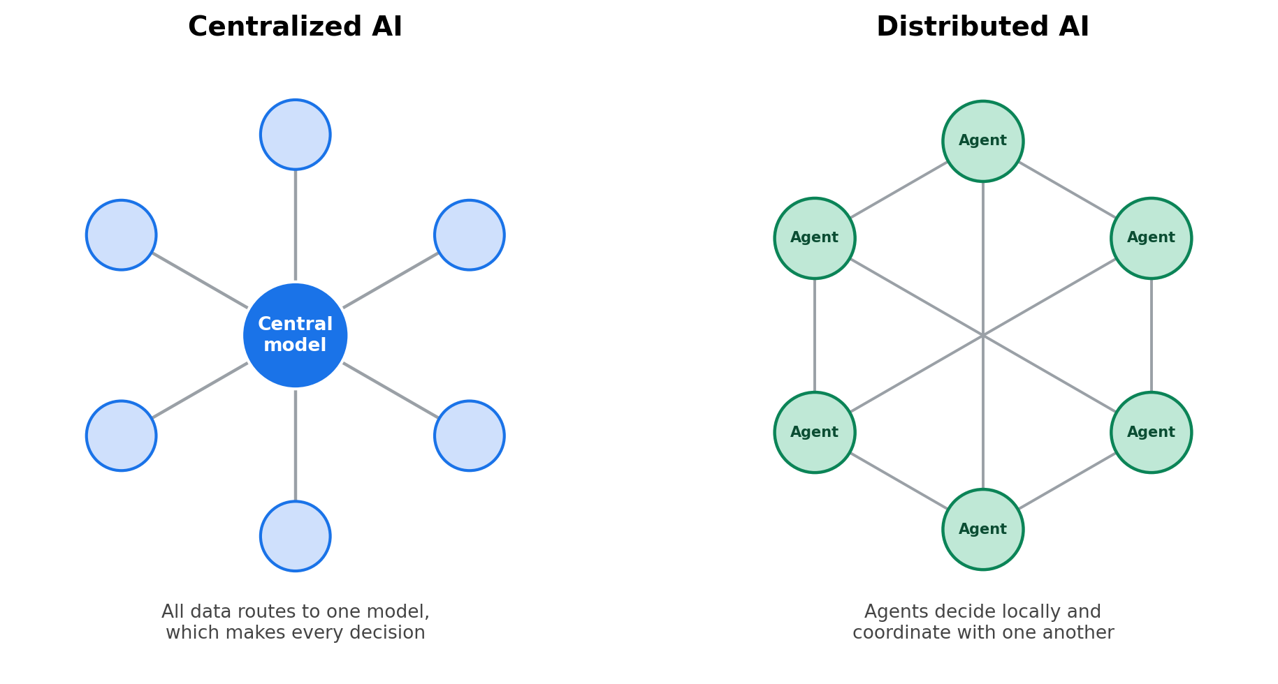
Note. In centralized AI, all data routes to one model that makes every decision. In distributed AI, autonomous agents make local decisions and coordinate with one another, so the system continues operating even if individual agents fail. Adapted from concepts in Distributed AI Systems (n.d.) and IBM (n.d.).
Application 1: Smart-Grid and Building Energy Management
Large infrastructure systems are a natural fit for distributed AI: every participant has different information and must act on local conditions, yet the whole still has to stay coordinated. Smart-grid energy management is a clear example.
The electric grid is becoming increasingly complex as rooftop solar systems, battery storage, and electric vehicles turn consumers into “prosumers” who both consume and generate power. A single controller cannot effectively manage every home, battery, and charging station in real time. Shojaeighadikolaei et al. (2022) describe a multi-agent deep reinforcement learning framework in which each prosumer operates its own intelligent agent. Those agents decide when to store energy, use it, or sell it back to the grid based on local conditions and pricing information.
Instead of one central controller making every decision, each participant responds to the information available to it. The grid operator still provides overall coordination, but the system does not depend on a single decision-maker. In facilities terms, this resembles demand-response strategies where loads can be shifted automatically across many assets rather than requiring manual intervention. Distributed AI allows the system to scale while remaining responsive to local conditions.
Application 2: Predictive Maintenance
Predictive maintenance is the application that feels most relevant to my day-to-day work. Instead of repairing equipment after failure or replacing components according to a fixed schedule, predictive maintenance uses sensors and analytics to identify problems before they become critical.
Fernández-Miguel et al. (2025) describe predictive-maintenance ecosystems built around edge computing, federated learning, and distributed intelligence. Monitoring agents on individual machines analyze equipment conditions locally, detect anomalies, and contribute information to a broader network without necessarily sharing raw operational data.
When I am troubleshooting a pump, booster heater, refrigeration system, or other piece of equipment, I am looking for signs that something is operating outside normal conditions. Distributed predictive-maintenance systems are doing something similar, except sensors are collecting information continuously and sharing lessons learned across an entire fleet of equipment. The value of distribution is that decisions can be made close to where the data is generated. A system does not need to wait for every reading to travel to a remote data center before responding to a potential problem. That speed can make a significant difference when preventing costly downtime.
One Challenge and One Advantage
The biggest practical challenge I see is interoperability. Distributed AI only works if agents can communicate effectively with one another. In the facilities world, it is common to see equipment from different manufacturers connected to software platforms from other vendors, and getting those systems to exchange information reliably can be difficult and expensive. The same problem exists in distributed AI: agents developed by different organizations may use different protocols, assumptions, or communication standards, and without effective integration the benefits of distribution become much harder to realize.
The advantage that stands out most is resilience. In a centralized architecture, failure of a critical controller can disrupt the entire system. In a distributed architecture, individual agents can fail while the rest of the network continues to operate. For applications involving power systems, manufacturing, transportation, or building operations, that fault tolerance is often more valuable than maximizing efficiency.
One question that emerged during my research is whether distributed AI also makes accountability more difficult. In a centralized system, it is usually clear where a decision originated. In a distributed system, an outcome may emerge from the interactions of dozens or hundreds of agents. The system may be more resilient, but determining responsibility for a bad decision could become more complicated.
What Surprised Me Most
Swarm intelligence caught me off guard — the idea, drawn from behaviors like ant colonies and bird flocks, that sophisticated coordination can emerge from many simple agents following local rules, with no central controller (Distributed AI Systems, n.d.). At first the examples reminded me of an assembly line, where each station performs one fixed task in a larger sequence. The more I sat with it, though, the more distributed AI reminded me of a musical ensemble.
As a musician, that comparison feels more honest than most technology analogies. In a band or orchestra there may be leadership and structure, but the performance depends on musicians constantly listening, adapting, and responding to one another in real time. No single player controls every note, yet the group produces something coordinated and often creative. The intelligence does not live in any one performer; it emerges from the interaction.
That reframing raises a question I keep returning to: are today's distributed AI systems truly collaborative like an ensemble, or are they still closer to an automated assembly line? Most current examples land somewhere in between. Either way, the notion that intelligence can arise from interaction rather than central control was the idea that stayed with me.
Conclusion
Distributed AI pushes decision-making out to where the data is, rather than routing everything through a central authority. Smart grids use it to balance supply and demand across millions of independent actors, and predictive maintenance uses it to catch failures early while keeping sensitive data local. The payoff is resilience, scalability, and responsiveness; the cost is harder problems in interoperability, accountability, and coordination.
Coming from facilities work, the resilience is what I value most. Buildings, utility systems, and maintenance programs tend to succeed because many independent parts keep working toward a shared goal even when one of them fails. But I am not convinced that today's systems deserve the ensemble label yet. Many still look more like an assembly line of specialized agents than a group genuinely adapting to one another. If distributed AI keeps moving toward the ensemble end of that spectrum, its most important feature may not be the intelligence of any single agent, but the intelligence that emerges between them.

References
Distributed AI systems: The collective intelligence of machines [Video]. (n.d.). YouTube. https://www.youtube.com/watch?v=cHTvVr1w_7s
Fernández-Miguel, A., Ortíz-Marcos, S., Jiménez-Calzado, M., Fernández del Hoyo, A. P., García-Muiña, F. E., & Settembre-Blundo, D. (2025). Agentic AI in smart manufacturing: Enabling human-centric predictive maintenance ecosystems. Applied Sciences, 15(21), 11414. https://doi.org/10.3390/app152111414
IBM. (n.d.). What is a multi-agent system? IBM. Retrieved September 16, 2026, from https://www.ibm.com/think/topics/multiagent-system
Shojaeighadikolaei, A., Ghasemi, A., Jones, K., Dafalla, Y., Bardas, A. G., Ahmadi, R., & Hashemi, M. (2022). Distributed energy management and demand response in smart grids: A multi-agent deep reinforcement learning framework. arXiv. https://doi.org/10.48550/arXiv.2211.15858

